**CSE 3902**

**Sprint 3 Reflection**

**Group Loading…**

Group Members: Ben Roth, Sean Burns, Alex Quedens, Jiayi Pu, Diya Adengada

[Trello Board](https://trello.com/b/b2owSuhc/3902)

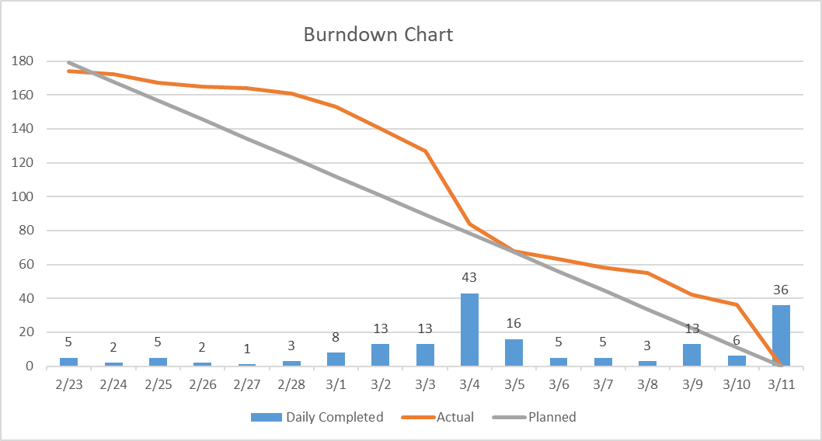

Despite this sprint being more technically challenging than Sprint 2, our team was still able to complete in on time and improve in areas mentioned during our last sprint review. We were able to get our code informally reviewed during class for quality, and make improvements based on the comments we received, such as ensuring Link doesn’t change direction when colliding with a block or wall.

We were able to divide our work pretty evenly; At the beginning of the sprint, we made a list of all the tasks that needed to be completed for this sprint, including room movement, wall and enemy collisions, and loading in the room backgrounds. Initially, three of our members worked on the room design component, while the other two worked primarily on collisions. In the last week of the sprint, however, we all collaborated to implement the last few features needed for the sprint, as well as to fix a couple of bugs that had arisen during the previous sprint, such as the enemy movement. For the next sprint, we would also like to focus more on code quality and ensuring any bugs are fixed.